**Aplikasi Sistem Pengarsipan Surat Robotika Polindra**

**Laporan**

Disusun untuk memenuhi salah satu tugas mata kuliah Manajemen Sistem Basis Data



Oleh :

**Aldini Eka Putri ; 1805004**

**Fikri Alfan Fasha; 1805011**

**Muhammad Pranata; 1805021**

**PROGRAM STUDI REKAYASA PERANGKAT LUNAK**

**POLITEKNIK NEGERI INDRAMAYU**

**KABUPATEN INDRAMAYU**

**2019**

1. **Pengguna Sistem :**

* Pengurus BPH (Admin)
* Anggota (User)

1. **Tahapan Normalisasi**
2. Unnormal Form

|  |  |  |  |  |  |  |  |  |  |  |  |  |  |  |  |  |  |
| --- | --- | --- | --- | --- | --- | --- | --- | --- | --- | --- | --- | --- | --- | --- | --- | --- | --- |
| Id_surat_masuk | Nomor_surat | Tgl_kirim | Tujuan | perihal | Id_surat_masuk | Nomor_surat | Tgl_kirim | Tujuan | perihal | Id user | No_anggota | Nama | Id_jabatan | Password | Id_jabatan | Nama | Level |
|  |  |  |  |  |  |  |  |  |  |  |  |  |  |  |  |  |  |
|  |  |  |  |  |  |  |  |  |  |  |  |  |  |  |  |  |  |

1. 1NF

|  |  |  |  |  |  |  |  |  |  |  |  |  |  |  |  |  |  |
| --- | --- | --- | --- | --- | --- | --- | --- | --- | --- | --- | --- | --- | --- | --- | --- | --- | --- |
| Id_surat_masuk | Nomor_surat | Tgl_kirim | Tujuan | perihal | Id_surat_masuk | Nomor_surat | Tgl_kirim | Tujuan | perihal | Id user | No_anggota | Nama | Id_jabatan | Password | Id_jabatan | Nama | Level |
|  |  |  |  |  |  |  |  |  |  |  |  |  |  |  |  |  |  |
|  |  |  |  |  |  |  |  |  |  |  |  |  |  |  |  |  |  |

1. 2NF

|  |  |  |  |  |
| --- | --- | --- | --- | --- |
| Id_surat_masuk | Nomor_surat | Tgl_kirim | Tujuan | perihal |
|  |  |  |  |  |

|  |  |  |  |  |
| --- | --- | --- | --- | --- |
| Id_surat_keluar | Nomor_surat | Tgl_terima | Tujuan | perihal |
|  |  |  |  |  |

|  |  |  |  |  |
| --- | --- | --- | --- | --- |
| Id_user | No_anggota | nama_user | Id_jabatan | Password |
|  |  |  |  |  |

|  |  |  |
| --- | --- | --- |
| Id_jabatan | Nama_jabatan | level |
|  |  |  |

1. **Relasi Antar Tabel**

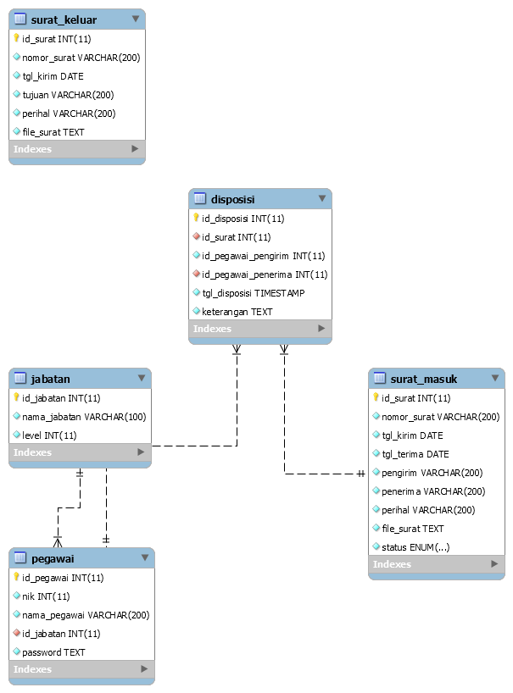

1. **Status hubungan Antar Tabel**



1. **Struktur Tabel**

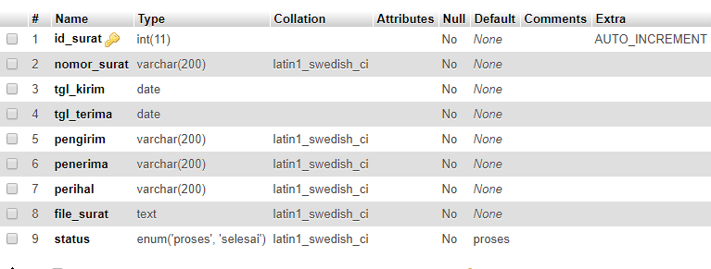

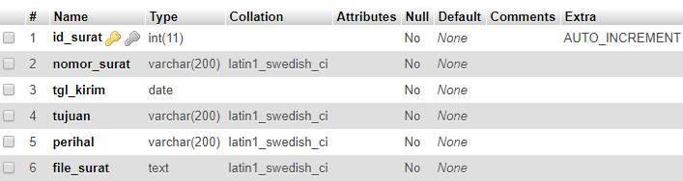

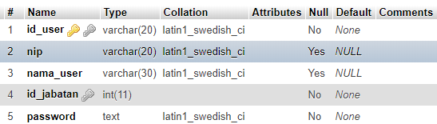

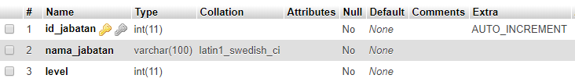

1. **Resume Akhir**

Sistem Pengarsipan Surat ini dibuat untuk UKM Robotika Polindra yang digunakan untuk pengarsipan surat baik itu surat masuk maupun surat keluar agar surat tersusun rapi.